/*

* KEY_LCD3mar.c

*

* Created: 03-04-2023 11:54:53

* Author : DSP LAB

*/

/*

4x4 Keypad Interfacing with ATmega16/32

http://www.electronicwings.com

*/

#include <avr/io.h>

#include <util/delay.h>

#define KEY_PRT PORTA

#define KEY_DDR DDRA

#define KEY_PIN PINA

#define LCD_Dir DDRB /* Define LCD data port direction */

#define LCD_Port PORTB /* Define LCD data port */

#define RS PB0 /* Define Register Select pin */

#define EN PB1 /* Define Enable signal pin */

unsigned char keypad[4][4] = { {'1','2','3','4'},

{'5','6','7','8'},

{'9','A','B','C'},

{'D','E','F','0'}};

unsigned char colloc, rowloc;

void LCD_Init (void) /* LCD Initialize function */

{

LCD_Dir = 0xFF; /* Make LCD port direction as o/p */

*_delay_ms*(20); /* LCD Power ON delay always >15ms */

LCD_Command(0x33);

LCD_Command(0x32); /* Send for 4 bit initialization of LCD */

LCD_Command(0x28); /* 2 line, 5*7 matrix in 4-bit mode */

LCD_Command(0x0c); /* Display on cursor off */

LCD_Command(0x06); /* Increment cursor (shift cursor to right) */

LCD_Command(0x01); /* Clear display screen */

}

void LCD_Command( unsigned char cmnd )

{

LCD_Port = (LCD_Port & 0x0F) | (cmnd & 0xF0);/* Sending upper nibble */

LCD_Port &= ~ (1<<RS); /* RS=0, command reg. */

LCD_Port |= (1<<EN); /* Enable pulse */

*_delay_us*(1);

LCD_Port &= ~ (1<<EN);

*_delay_us*(20);

LCD_Port = (LCD_Port & 0x0F) | (cmnd << 4);/* Sending lower nibble */

LCD_Port |= (1<<EN);

*_delay_us*(1);

LCD_Port &= ~ (1<<EN);

*_delay_ms*(2);

}

void LCD_Data( unsigned char data )

{

LCD_Port = (LCD_Port & 0x0F) | (data & 0xF0);/* Sending upper nibble */

LCD_Port |= (1<<RS); /* RS=1, data reg. */

LCD_Port|= (1<<EN);

*_delay_us*(1);

LCD_Port &= ~ (1<<EN);

*_delay_us*(20);

LCD_Port = (LCD_Port & 0x0F) | (data << 4); /* Sending lower nibble */

LCD_Port |= (1<<EN);

*_delay_us*(1);

LCD_Port &= ~ (1<<EN);

*_delay_ms*(2);

}

char keyfind()

{

while(1)

{

KEY_DDR = 0xF0; /* set port direction as input-output */

KEY_PRT = 0xFF;

do

{

KEY_PRT &= 0x0F; /* mask PORT for column read only */

asm("NOP");

colloc = (KEY_PIN & 0x0F); /* read status of column */

}while(colloc != 0x0F);

do

{

do

{

*_delay_ms*(20); /* 20ms key debounce time */

colloc = (KEY_PIN & 0x0F); /* read status of column */

}while(colloc == 0x0F); /* check for any key press */

*_delay_ms* (40); /* 20 ms key debounce time */

colloc = (KEY_PIN & 0x0F);

}while(colloc == 0x0F);

/* now check for rows */

KEY_PRT = 0xEF; /* check for pressed key in 1st row */

asm("NOP");

colloc = (KEY_PIN & 0x0F);

if(colloc != 0x0F)

{

rowloc = 0;

break;

}

KEY_PRT = 0xDF; /* check for pressed key in 2nd row */

asm("NOP");

colloc = (KEY_PIN & 0x0F);

if(colloc != 0x0F)

{

rowloc = 1;

break;

}

KEY_PRT = 0xBF; /* check for pressed key in 3rd row */

asm("NOP");

colloc = (KEY_PIN & 0x0F);

if(colloc != 0x0F)

{

rowloc = 2;

break;

}

KEY_PRT = 0x7F; /* check for pressed key in 4th row */

asm("NOP");

colloc = (KEY_PIN & 0x0F);

if(colloc != 0x0F)

{

rowloc = 3;

break;

}

}

if(colloc == 0x0E)

return(keypad[rowloc][0]);

else if(colloc == 0x0D)

return(keypad[rowloc][1]);

else if(colloc == 0x0B)

return(keypad[rowloc][2]);

else

return(keypad[rowloc][3]);

}

int main(void)

{

LCD_Init();

while(1)

{

// LCD_Command(0xc0);

LCD_Data(keyfind()); /* Display which key is pressed */

}

}

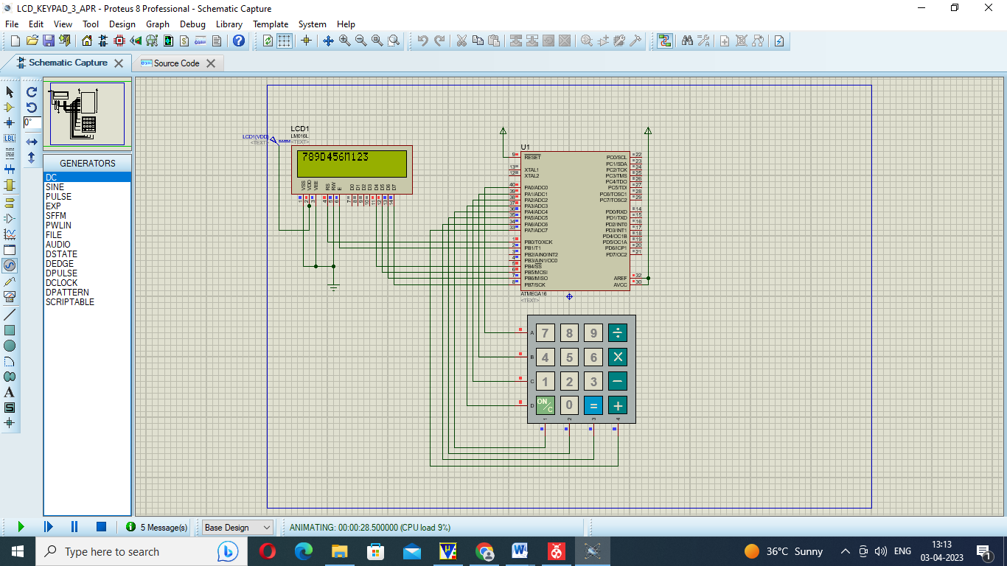

KAY_LCD3MAR – FILE (ATMEL STUDIO )

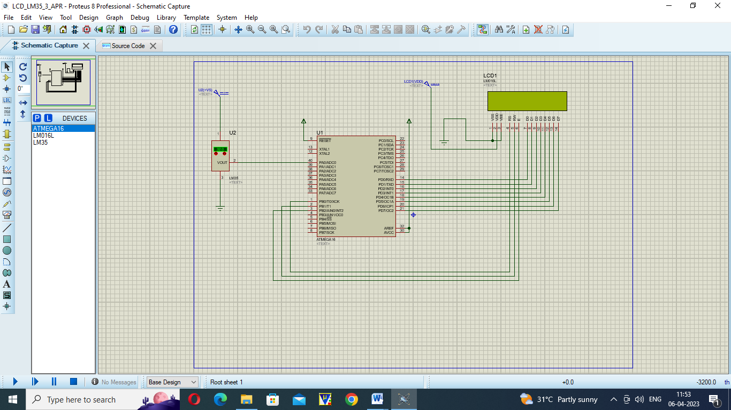

/*

* LCD_LM35_3_APR.c

LM35 Interfacing with ATmega16/32

*

* Created: 03-04-2023 13:43:21

* Author : DSP LAB

*/

#include <avr/io.h>

#include <util/delay.h>

#include <string.h>

#include <stdio.h>

#define LCD_DATA PORTD // LCD data port

#define ctrl PORTB

#define rs PB0 // register select signal

#define rw PB1 // read/write signal

#define en PB2 // enable signal

void LCD_init(void);

void LCD_cmd(unsigned char cmd);

void LCD_write(unsigned char data);

void ADC_Init(){

DDRA&= ~(1<0); /* Make PA0 an input for ADC */

ADCSRA = 0x87; /* Enable ADC, with freq/128 or ck/128 */

ADMUX = 0xE0; /* 2.56 V Vref and ADC0 signle ended data will be left justified */

}

void LCD_init(void)

{

LCD_cmd(0x38); // initialization of 16X2 LCD in 8bit mode

*_delay_ms*(1);

LCD_cmd(0x01); // clear LCD

*_delay_ms*(1);

LCD_cmd(0x0E); // cursor ON

*_delay_ms*(1);

LCD_cmd(0x80); // ---8 go to first line and --0 is for 0th position

*_delay_ms*(1);

return;

}

void LCD_cmd(unsigned char cmd)

{

LCD_DATA=cmd;

ctrl =(0<<rs)|(0<<rw)|(1<<en); // RS and RW as LOW and EN as HIGH

*_delay_ms*(1);

ctrl =(0<<rs)|(0<<rw)|(0<<en); // RS, RW , LOW and EN as LOW

*_delay_ms*(50);

return;

}

void LCD_write(unsigned char data)

{

LCD_DATA= data;

ctrl = (1<<rs)|(0<<rw)|(1<<en); // RW as LOW and RS, EN as HIGH

*_delay_ms*(1);

ctrl = (1<<rs)|(0<<rw)|(0<<en); // EN and RW as LOW and RS HIGH

*_delay_ms*(50); // delay to get things executed

return ;

}

int main()

{

unsigned char Vout, x,d1,d2;

//float Vout;

DDRD=0xff; // making LCD_DATA port as output port

DDRB=0x07; // making signal as out put

LCD_init(); // initialization of LCD

*_delay_ms*(5); // delay of 50 milli seconds

LCD_write('T'); // call a function to write A on LCD

LCD_write('e'); // call a function to write A on LCD

LCD_write('m'); // call a function to write A on LCD

LCD_write('p'); // call a function to write A on LCD

LCD_write('='); // call a function to write A on LCD

ADC_Init(); /* initialize ADC*/

while(1)

{

ADCSRA |=(1<<ADSC);

while((ADCSRA&(1<<ADIF))==0); // finidhes conversion

Vout=ADCH;

// Vout=(ADC_Read(0)*(5/1024));

//Vout1=Vout*100;

x=Vout/10; // suppose x=32 then x=32/10

d1=x; // d1=3

d2=(Vout)%10; // d2=32%10 hence d2=2

//celsius = (ADC_Read(0)*4.88);

//celsius = (celsius/10.00);

LCD_write(d1+0x30);

LCD_write(d2+0x30);

*_delay_ms*(1000);

}

}

Exp-7 Serial_comm

#define *F_CPU* 12000000UL

#include <avr/io.h>

#include <util/delay.h>

#include <stdlib.h>

#include <stdio.h>

unsigned char data;

//Function for character receiving on Rx pin

//BAUD = Baud rate (in bits per second, bps)

//fosc = System Oscillator clock frequency

//UBRR = Contents of the UBRRH and UBRRL Registers, (0 - 4095)

// system frequency =12Mhz

// Set Baud Rate = 9600 then,

//BAUD=9600

//fosc= 12Mhz

//Then according to above given formula:

//UBRR = (12000000/(16x9600)) - 1

// UBRR = 77.125 which is quite near to 77.WHICH IS EQUV=0X4D

//UBRRH=0x00;

//UBRRL=0x4d;

unsigned char uart_receive ()

{

while((UCSRA&(1<<RXC)) == 0);

// wait untill 8-bit of a character receive

return UDR;

}

//Functions transmit data

void uart_transmit (unsigned char data)

{

while (!( UCSRA & (1<<UDRE)));

// wait for the register to free from data

UDR = data;

// load data in the register

}

//Main function

int main()

{

//UART initialization

UBRRH=0x00;

UBRRL=0x4d; // To set the Buad rate to 9600.. get value through above formula

UCSRB=(1<<RXCIE) | (1<<RXEN) | (1<<TXEN);

UCSRC=(1<<URSEL) | (1<<UCSZ1) | (1<<UCSZ0) ;

while(1){

data=uart_receive(); // MC will wait here infinitly to get a 8-bit character

//the functions below will print the every character three times

uart_transmit(data);

uart_transmit(data);

uart_transmit(data);

}

}